LEAZES HOMES
About Us

Background:
Leazes Homes is an affordable housing provider based in Newcastle upon Tyne. We offer a range of housing options to those in need, from family homes to supported living for older people and those with additional care needs. Leazes Homes was incorporated in 2009 as a company limited by guarantee and granted charitable status in January 2010.
Since it was established in 2009, Leazes Homes’ primary objective has been to provide high quality, affordable accommodation to people in need. The main target area for this activity has historically been in Newcastle upon Tyne. This objective has been delivered through working in partnership with key organisations in the affordable housing sector such as Homes England.
Leazes Homes is a Registered Provider of Social Housing with a current stock of 760 properties. A large proportion of our stock is supported housing, providing homes for people with care and support needs.

Joining Your Homes Newcastle (YHN):
On 6 August 2021 Leazes Homes became a subsidiary of Your Homes Newcastle (YHN), the arms-length management organisation responsible for managing Newcastle City Council’s tenancies and at the same time changed its legal structure to become an Exempt Charity and Community Benefit Society.
The decision by Leazes Homes and YHN to join together builds on the longstanding relationship that already existed between the organisations, with YHN having provided housing management services to Leazes Homes.
As a subsidiary of the YHN Group, Leazes Homes remains a separate company in its own right, with its own Board and overseen by the Regulator for Social Housing. Leazes Homes’ assets also remain within the ownership of Leazes Homes.
Under the new structure, Leazes Homes Board will help develop and implement the supported housing vision for the YHN Group by taking responsibility for the strategic leadership and oversight of the supported housing provision for both partners, which includes support and progression, employability, Housing Plus and safeguarding services . YHN, while retaining responsibility for the group as a whole, will focus on the strategic and operational oversight of general needs accommodation and services.
The new structure provides Leazes Homes’ Board with the opportunity to progress its ambitions around developing exemplar accommodation solutions in the supported housing market, by being able to access additional capacity, knowledge and resources that exists within YHN. At the same time the move builds on the close relationship with both YHN and Newcastle City Council as our key stakeholder.
Day to day operations for the Group are undertaken by the YHN Executive Team, and it is the central role of Leazes Homes Board to direct them and to make decisions that are in the best interests of customers and delivery of services.

What We Provide
Leazes Homes provides the following types of accommodation:-
General Needs Housing - Leazes Homes currently has almost 400 “general needs” properties across a number of sites within Newcastle, including brand new homes and beautifully refurbished older buildings, such as park lodges. All of our general needs properties are advertised and allocated through Tyne and Wear Homes.
Older Person’s Housing - Leazes Homes has a range of different properties that are designed to meet the needs of older people, including more traditional sheltered housing schemes, independent living in level access bungalows, assisted living and extra care schemes and accommodation specifically designed for people with dementia
Specialist Housing - At Leazes Homes, we recognise that some people need support to live independently, and we’ve developed lots of properties that help people with particular needs. This includes specially adapted bungalows for people with physical disabilities, assisted living for adults with learning disabilities, and specialist schemes for adults with autism and other complex needs.

Going forward there will continue to be a focus on ensuring effective management of our existing housing schemes for the benefit of tenants and residents and also on developing exemplar accommodation solutions in the supported housing market.

The Board
There are currently 6 board members (1 appointed by YHN and 5 independent members.) The organisation is now looking to appoint a further two independent board members with backgrounds in Supported Housing Services/Development and Asset Management/Repairs management Services.
Current Board members come from a variety of backgrounds including Social Housing, Local Authority and the private sector each bringing valuable knowledge and experience to the role. The current Chair of Leazes Homes is Dawn Keightley.

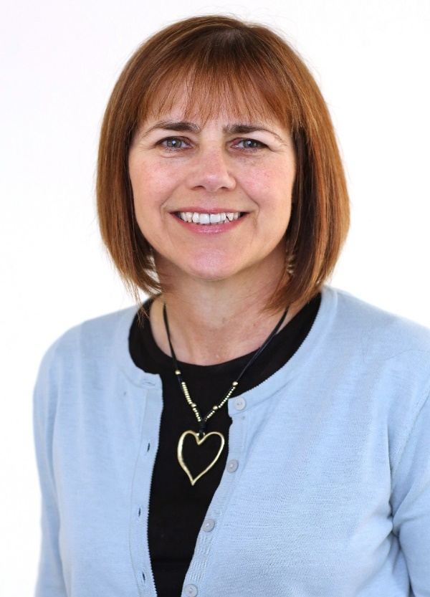
Dawn Keightley, Chair of Leazes Homes
Dawn Keightley was appointed as a Leazes Homes Trustee in April 2017 and became Chair in August 2018. She has spent over two decades in the social housing sector, mainly working for a national provider of supported housing and latterly for a regional provider in a range of strategic roles. Dawn previously worked with NHS England Transforming Care Programme focusing on increasing housing choices for people with learning disabilities and/ or Autism and she's currently the Managing Director of a registered provider of social housing in the North East.
Ged Walsh, Vice Chair of Leazes Homes
Ged was appointed as a Leazes Homes Trustee in April 2018. Ged's last full time role was as Director of Development and Assets at Karbon Homes and he has over 30 years of experience working in the construction and housing sectors. Ged is a chartered surveyor and, during his career, worked for several large social housing organisations as well as for Homes England. He is also now Development Committee Member for Gentoo housing in Sunderland.
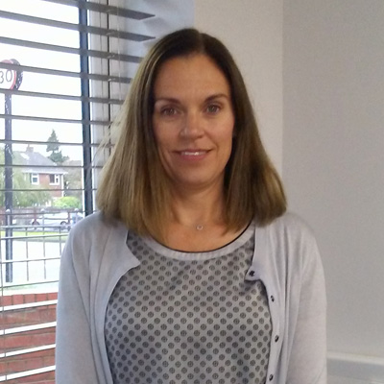
Kath Heathcote, Leazes Homes Trustee
Kath is a housing professional who has held several senior positions in housing, including Head of Housing for Derwentside District Council. Over her career Kath has managed a range of services and has experience and expertise in supported housing, which is particularly relevant to Leazes Homes. Kath currently undertakes interim management and consultancy roles and this experience of different organisations and ways of working, along with her experience and expertise in housing is a great addition to the Board of Leazes Homes.
William Thompson, Leazes Homes Trustee
William was appointed as a Leazes Homes Trustee in April 2018. He is a non-practising qualified solicitor with health & safety qualifications and over 30 years' operational experience in the field of waste, recycling, land regeneration and sustainability in the North East. During his career, William has held several directorships and company secretary positions, and is the Group Company Secretary at Northumberland County Council.
Jon Ritchie, Leazes Homes Trustee
Jon is a Chartered Accountant and is currently Executive Director of Corporate Services at Sunderland City Council. He is the Council’s statutory Chief Finance Officer, a role that is responsible for the management of the Council’s £600m revenue budget and £200m capital programme. He also oversees a range of corporate services, including legal, HR, procurement, IT and corporate affairs. Prior to moving to Sunderland in 2018, he has held a range of senior finance posts working in and with local authorities, including Your Homes Newcastle and North Tyneside Council
Cllr Linda Hobson, YHN representative
Linda was appointed to the Board by Newcastle City Council in May 2019. She was first elected to Newcastle City Council in 2011 and is the Labour Councillor for Blakelaw Ward where she grew up. Linda is a Registered Nurse, a lead activist for UNISON, and a graduate of Labour’s first Jo Cox Women in Leadership programme. She has worked within the NHS since 1997 and has lived in Newcastle all her life. Linda was previously the Cabinet Member for Adult Services and is now Cabinet member for Housing. Linda was appointed to the Leazes Homes Board as the YHN representative in July 2021.

Board Members make decisions that benefit the majority of tenants and act in the best interests of the organisation. All Members sign a Board Member Code of Conduct which defines the standards required and helps the Board maintain its reputation for integrity.

Executive Team
Tina Drury, Managing Director
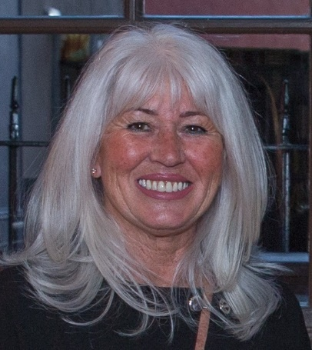
Hailing from Kenton in Newcastle, Tina started her career in 1982 as a clerk at the City Council's housing department. Since then, she has developed her career at a number of housing associations, helping transform homes and housing services in the region in previous executive roles at South Tyneside Homes, Castle Morpeth Housing and the Isos Group, where she was Group Executive Director (Customers and Communities). Tina joined YHN as its Managing Director in 2016.

David Langhorne, Assets and Development Director
David has worked for YHN for over ten years. In 2005 he left Northumberland County Council to join YHN as the Investment Planning Manager charged with undertaking one of the largest housing investment programmes the region has seen. David became Head of Service in 2009, then Director of Property Services in 2013, later Assets and Development Director in 2017. His responsibilities cover technical services, property maintenance, investment programmes, repairs and maintenance and health and safety.

Greg van-Enk Bones, Finance Director
Greg joined YHN as Finance Director in March 2020 after working in housing finance for the past 18 years. He brings with him a wealth of experience, with over a decade spent in non-executive Board roles and Executive Director positions in Finance, ICT, Governance and HR, as well as Development, Assets and Estates Management. As part of his MBA at Manchester Business School, Greg specialised in how regulations and culture impact on Value for Money in Housing Associations. Greg is a qualified accountant and a Fellow of the Association of Chartered Certified Accountants (FCCA).
Jen Vinton, Customer Services Director
Jen oversees YHN’s housing customer and supported services functions. She has a long career working in customer focused roles, which began at Tyne and Wear County Council in 1983. From there, she moved into a Clerical Assistant role in the old housing department at Newcastle City Council. She has developed her career within housing in Newcastle through a number of different roles primarily within investment delivery, regeneration and development. Jen is incredibly passionate about providing excellent customer service and putting customers at the heart of everything we do.

