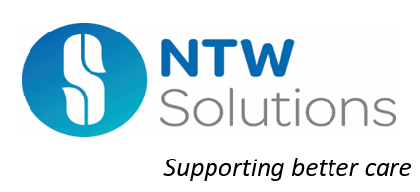

NTW Solutions Limited

Chair of the Board Vacancy
Candidate Pack

NTW Solutions Limited

Chair of the Board
Typically, 2 days per month per month (equivalent)

Remuneration £6,750 We are seeking to appoint a Non-Executive Director to join our Board in the role of Chair. The role will require individuals whose personal values are aligned to those of the NHS, the Company and the Trust.

You will work as part of the Board of Directors and will play a key role in shaping and delivering the company’s strategy as the company continues to develop. It is a role which requires you to help us to fulfil our vision.

As part of the recruitment and appointment process we are committed to doing everything we can to promote and ensure diversity within our senior leadership team.

We know there is evidence that diverse Boards make the best decisions, and we want to take positive action to increase the diversity of our workforce, including the Board of Directors

We would welcome applications from people from Black, Asian and Minority Ethnic backgrounds, and people with other protected characteristics, including consideration of gender-balance on the Board.

We value and promote diversity and are committed to equality of opportunity for all and all appointments are made on merit. We believe that the best boards are those that reflect the communities they serve.

We would welcome applications from people with
significant and senior experience in Commerce and Business including contracting and project management, customer or back-office services or estates and construction services. The role does not require NHS experience.

Closing date for applications: Midnight 29th September 2021

NTW Solutions Limited

NTW Solutions is a wholly owned subsidiary of Cumbria, Northumberland Tyne and Wear which became operational in April 2017. Wholly owned subsidiary
companies are an organisational and governance form that NHS Foundation Trusts
can legally establish to manage part of their organisation. Wholly owned subsidiary
companies are separate legal entities. NTW Solutions Limited is part of the “CNTW
Group”, sharing the vision and values of the Trust in carrying out its activities, with
the Trust holding 100% of the Company’s shares.

NTW Solutions provides our estates and facilities management services and a
range of other services including workforce recruitment; staff records; procurement;
materials management; some financial services; car leasing and other staff benefit
schemes; digital dictation; and outpatient pharmacy dispensing. It employed 629
staff (physical number of staff not full-time equivalents) at the end of 2019/20. Initially the majority of staff were transferred from the Trust to the company under TUPE regulations, thereby protecting many of their NHS terms and conditions. Approximately 50% of the staff have been appointed since April 2017 and are employed on company terms and conditions of service,

Our commitment to Equality, Diversity, and Inclusion

Equality is about creating a fairer society where everyone has the opportunity to fulfil their potential. Diversity is about recognising and valuing difference in its broadest sense. Inclusion is about an individual's experience within the workplace and in wider society and the extent to which they feel valued and included.

We commit to promoting equality, fairness, and respect for all in our employment, whether temporary, part-time, or full-time.

We are working hard together with the Trust’s staff Networks: BAME Network; LGBT+ Network; Disability Network; and Mental Health and Well Being Network, to prevent discrimination of any kind. This includes creating a working environment free of bullying, harassment, victimisation, and unlawful discrimination, promoting dignity and respect for all, and where individual differences and the contributions of all colleagues are recognised and valued.

Promoting equality, diversity and inclusion is at the heart of our values. We aim to employ a workforce which is as representative as possible of our local population including ensuring our Board of Directors are representative of the communities we serve.

On this basis, we are actively seeking applications from people from Black, Asian and Minority Ethnic backgrounds, and people with other protected characteristics.

Our Vision, Values, Quality Goals and Strategic Objectives.

‘Providing services that make a difference through values that matter”

Our vision is underpinned by a set of strategic priorities which were developed in consultation with our stakeholder (the Trust) and our staff.

. 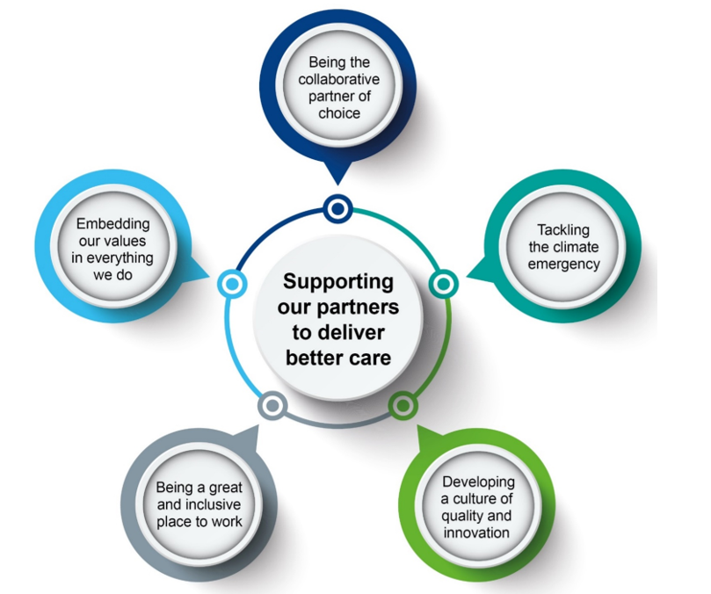

The Company has just launched a refresh of its strategy taking an inclusive approach over an eighteen-month period based on engagement and feedback from: our shareholders, our senior managers, and our workforce

The Role of the Board of Directors

The Board of Directors consists of three Non-Executive Directors including the Chair and three Executive Directors including the Managing Director. They are collectively responsible for the exercise of the powers and the performance of the Company.

As a unitary Board all directors have joint responsibility for every decision of the Board of Directors and share the same liability. This does not impact upon the particular responsibilities of the Managing Director as the accounting officer.

The general duty of the Board and of each director individually, is to act with a view to promoting the success of the company so as to maximise the benefits for the members of the Group as a whole

Its role is to provide entrepreneurial leadership of the Company within a framework of prudent and effective controls, which enables risk to be assessed and managed. It is responsible for:

- Ensuring the quality and safety of services provided to the Shareholder and applying standards of governance set out by Companies House.
- Setting the Company’s vision, values and standards of conduct and ensuring that its obligations to its members are understood, clearly communicated and met. In developing and articulating a clear vision for the Company, it should be a formally agreed statement of the Company’s purpose and intended outcomes which can be used as a basis for the company strategy, planning and other decisions.
- Ensuring compliance including mandatory guidance, relevant statutory requirements and contractual obligations.
- Setting the Company’s strategic aims at least annually, taking into consideration the views of the Stakeholder, ensuring that the necessary financial and human resources are in place for the Company to meet its priorities and objectives and then periodically reviewing progress and management performance.
- Ensuring that the Company exercises its functions effectively, efficiently and economically.

The Board of Directors keeps its performance and effectiveness under on-going review. It undertakes a self-assessment of effectiveness supported by post Board of Directors’ meeting reflections, a development programme, the review of governance arrangements and its committees’ annual self-assessment exercise.

The Board of Directors maintains continuous oversight of the Company’s risk management and internal control systems with regular reviews covering all material controls, including financial, operational and compliance controls. The Board of Directors reports on internal control through the Annual Governance Statement as part of the Annual Report and Accounts.

The Board of Directors meets ten times per year (excluding development sessions)

The appointment of the Chair requires approval by the Trust.

Chair Role Description

Accountable to: Chairman of the Council of Governors and Board of Directors of CNTW

Location: Home based, travel to various trust sites is required.
Time commitment: Approximately 2 days per month
Remuneration: £6,750 allowance
Term of appointment: Three years with an opportunity to renew or re-apply

Overall purpose

- Commit to working to, and encouraging within the Company, the highest standards of probity, integrity and governance and contribute to ensuring that the company’s internal governance arrangements conform to best practice and statutory requirements.
- Provide independent judgement and advice on issues of strategy, vision, performance, resources, and standards of conduct and constructively challenge, influence, and help the executive board develop proposals on such strategies.
- In accordance with agreed board procedures, monitor the performance and conduct of management in meeting agreed goals and objectives and statutory responsibilities, including the preparation of annual reports and annual accounts and other statutory duties.

Responsibilities

- Contribute to the determination of appropriate levels of remuneration for Executive Directors.
- Bring independent judgement and experience based on commercial, financial, capital investment and governance expertise from outside the company and apply this to the benefit of the Group, its stakeholders and its wider community.
- Assist fellow directors in setting the company’s strategic priorities, ensuring that the necessary financial and human resources are in place for the company to meet its objectives, and that performance is effectively monitored and reviewed.
- Assist fellow directors in providing entrepreneurial leadership to the company within a framework of prudent and effective controls, which enable risk to be assessed and managed.
- Assist fellow directors in setting the company’s values and standards and ensure that its obligations to its stakeholders and the wider community are understood and fairly balanced at all times.
- Engage positively and collaboratively in board discussion of agenda items and act as an ambassador for the company in engagement with stakeholders including the local community, dealing with the media when appropriate.

Communications and Working Relationships
- Ensure the effectiveness and constructive dialogue and promote harmonious relations with the following Trust bodies as requested:
  - Board of Directors
  - Council of Governors
  - Stakeholders in the trust’s community
  - National healthcare stakeholders; and
  - Regulators including NHS England/NHS Improvement and the Care Quality Commission
- Participate when requested in the work of the Trust Board of Directors and of governors and maintain appropriate links with the Chief Executive and individual directors, as well as with the wider local and national health and social care community.
- Develop high level relationships with key stakeholders, including the Company’s financiers, but ensuring that the interests of all stakeholders are fairly balanced at all times.
- Bring balance to the use and influence of external advisers.
- Represent the company’s views with national, regional, or local bodies or individuals and ensure that the views of a wide range of stakeholders are considered.

Corporate Responsibilities

- To work at all times in the interests of the Group.
- Contribute to the strategic vision of the company and the identification of the company’s objectives.
- Ensure compliance with all corporate governance and statutory requirements.
- Responsible for own health and safety and the health and safety others at work.
- Uphold the values of the company, to be an appropriate role model and to ensure that the board promotes equality and diversity for all its staff and other stakeholders.
- Be an ambassador for the company, be knowledgeable and aware of local issues and assist the company in its efforts to support local regeneration as a major employer.
- Set an example on all policies and procedures designed to ensure equality of employment; Staff, patients and visitors must be treated equally irrespective of gender, ethnic origin, age, disability, sexual orientation, religion etc.

Personal Responsibilities

- Take responsibility for self-development on a continuous basis, undertaking this in work or development opportunities as appropriate.
- Participate in personal objective setting and review, including the creation of a personal development plan.
- Act as an ambassador for the company and its services.
- Promote the objectives and ethos of the Company at all times.
- Respect confidentiality of any confidential information shared during the course of employment.
- To contribute to the work of the board through debate, scrutiny and challenge with particular focus on issues of strategy, performance and governance.

Person Specification

E = Essential D = Desirable

Qualifications

Professional qualification in a relevant discipline or relevant experience E
Degree or equivalent D
Further qualification in management D

Experience

Experience of leadership in a large and complex organisation E
Experience at board level in a large and complex organisation D
Experience in chairing boards or committees D

Skills and Abilities

Highly developed leadership skills E
Excellent communication skills E
Effective influencing skills E
Sound networking skills E
Highly developed analytical skills E
Highly developed interpersonal skills E
Effective team player E
Ability to provide constructive challenge E
Ability to manage conflict E

Knowledge

Best practise in corporate governance E
Strategy development E
Performance management E
Broad understanding of the NHS D

Personal Attributes

Politically aware E
Gravitas E
Assertive E
Pro-active E
Enquiring E
Sound judgement E
Commitment to self-development E

The Company would welcome applications from candidates with any of the following backgrounds with significant and senior experience in:

Commerce and Business
- Contracting and project management
- Customer or back-office services
- Estates and construction services

We value and promote diversity and are committed to equality of opportunity for all and all appointments are made on merit. We believe that the best boards are those that reflect the communities they serve, we particularly welcome applications from women, people from the black and minority ethnic communities, and disabled people who we know are under-represented in non-executive roles.

How to Apply

Applications can be made via http://trac.jobs/ or https://www.jobs.nhs.uk/

If you have any queries, please contact Debbie Henderson, Director of Communications and Corporate Affairs

Telephone: 0191 2457290 or 0191 2456823
Email: Debbie.Henderson@ntw.nhs.uk

Application Process

The closing date for applications: Midnight 29 September 2021

Shortlisted candidates will have the opportunity to informally meet the Managing Director prior to the formal interviews which will be held on 19th October 2021.

This is a Shareholder led appointment and the Panel will comprise of Members of the Nominations Committee who will make a recommendation to the Council of Governors at a general meeting after which a formal offer will be made to the successful candidate.

