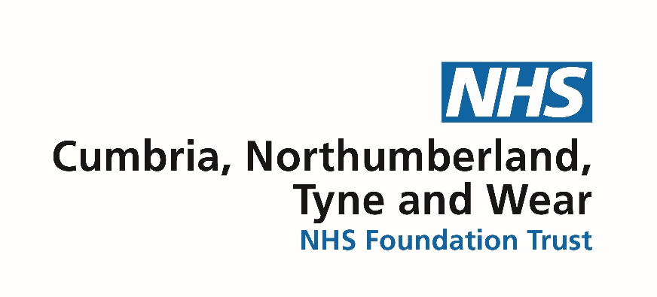

Non-Executive Director Vacancy

Candidate Pack

Cumbria, Northumberland, Tyne and Wear NHS Foundation Trust

Non-Executive Director
Typically 4 days per month (equivalent)

Remuneration £13,500 per annum

We are seeking to appoint a Non-Executive Director to join our Board. The role will require individuals whose personal values are aligned to those of the NHS and of CNTW (see page 6).

You will work as part of the Board of Directors and will play a key role in shaping and delivering the Trust’s strategy as the NHS continues to develop. It is a role which requires you to help us to fulfil our vision of championing those we serve and you will need empathy, compassion and the ability to connect with service users, their families and their carers.

As part of the recruitment and appointment process we are committed to doing everything we can to promote and ensure diversity within our senior leadership team.

We know there is evidence that diverse Boards make the best decisions, and we want to take positive action to increase the diversity of our workforce, including the Board of Directors. More information on our commitment to Equality, Diversity and Inclusion is provided on page 5.

We would welcome applications from people from Black, Asian and Minority Ethnic backgrounds and people with other protected characteristics, including consideration of gender-balance on the Board.

We value and promote diversity and are committed to equality of opportunity for all and all appointments are made on merit. We believe that the best boards are those that reflect the communities they serve.

Throughout this application pack, you will see that we would welcome applications from people with experience in commercial and business planning including contracting and project management, experience of leading through complex change management would be welcome, as well as understanding of managing significant business transactions, and organisational business planning.

Closing date for applications: Midnight 29 September 2021

Cumbria, Northumberland, Tyne and Wear NHS Foundation Trust

The Trust works from more than 70 sites across North Cumbria, Northumberland, Newcastle, North Tyneside, Gateshead, South Tyneside, Sunderland and Middlesbrough. We also run a number of regional and national specialist services. Along with partners, we deliver support to people in their own homes, and from community and hospital-based premises, making CNTW one of the largest NHS Foundation Trusts of its kind in the country. We have more than 7,000 people working for us and a budget of over £380 million.

In August 2016 we were rated ‘Outstanding’ by the Care Quality Commission, one of the first mental health Trusts in the country to achieve this. In 2018 we were again awarded an ‘Outstanding’ rating.

The Trust was chosen by NHS Improvement to lead the way in mental health care, picking us as its strategic partner in developing its mental health improvement programme.

At the heart of all we do is a commitment to developing services that enable and empower our service users to reach their potential and live fulfilling lives.

Background information

CNTW was formed in 2019 when the mental health and learning disability services in North Cumbria were transferred to Northumberland, Tyne and Wear NHS Foundation Trust. Northumberland, Tyne and Wear NHS Foundation Trust was created in 2006. This was through the merger of three different NHS trusts: Newcastle, North Tyneside and Northumberland Mental Health NHS Trust; South of Tyne and Wearside Mental Health NHS Trust; and Northgate and Prudhoe NHS Trust.

Since then, there have been some dramatic changes that have helped shape how we care and support the people we serve. For instance, we have been able to provide some state-of-the-art facilities, which have dramatically improved inpatient services.

The Trust provides support to people in the communities of North Cumbria, Northumberland, Newcastle, North Tyneside, Gateshead, South Tyneside, Sunderland and Middlesbrough working with a range of partners to deliver care and support to people in their own homes and from community and hospital-based premises. Our main hospital sites are:

    - Walkergate Park, Newcastle upon Tyne;
    - St. Nicholas Hospital, Newcastle upon Tyne;
    - St. George’s Park, Morpeth;
    - Northgate Hospital, Morpeth;
    - Hopewood Park Hospital, Sunderland;
    - Monkwearmouth Hospital, Sunderland;
    - Ferndene, Prudhoe;
    - Carleton Clinic, Cumbria.
    - Hadrian Clinic and Older People’s Services Campus of Ageing and Vitality, Newcastle upon Tyne

Foundation Trusts are independent, public benefit organisations adhering to NHS principles and working in partnership with the private sector and with the Third Sector.

Our commitment to Equality, Diversity and Inclusion

Equality is about creating a fairer society where everyone has the opportunity to fulfil their potential. Diversity is about recognising and valuing difference in its broadest sense. Inclusion is about an individual's experience within the workplace and in wider society and the extent to which they feel valued and included (NHS Employers).

We commit to promoting equality, fairness and respect for all in our employment, whether temporary, part-time or full-time, as well as for volunteers.

We are working hard together with our staff Networks: BAME Network; LGBT+ Network; Disability Network; and Mental Health and Well Being Network, to prevent discrimination of any kind. This includes creating a working environment free of bullying, harassment, victimisation and unlawful discrimination, promoting dignity and respect for all, and where individual differences and the contributions of all colleagues are recognised and valued.

Promoting equality, diversity and inclusion is at the heart of our Trust values. We aim to employ a workforce which is as representative as possible of our local population including ensuring our Board of Directors are representative of the communities we serve.

On this basis, we are actively seeking applications from people from Black, Asian and Minority Ethnic backgrounds and people with other protected characteristics.

Our Vision, Values, Quality Goals and Strategic Objectives

‘To be a leader in the delivery of high-quality care and a champion for those we serve’

Our vision is underpinned by a set of core values which we developed in consultation with a range of stakeholders, including service users, carers, staff, Governors and partner organisations.
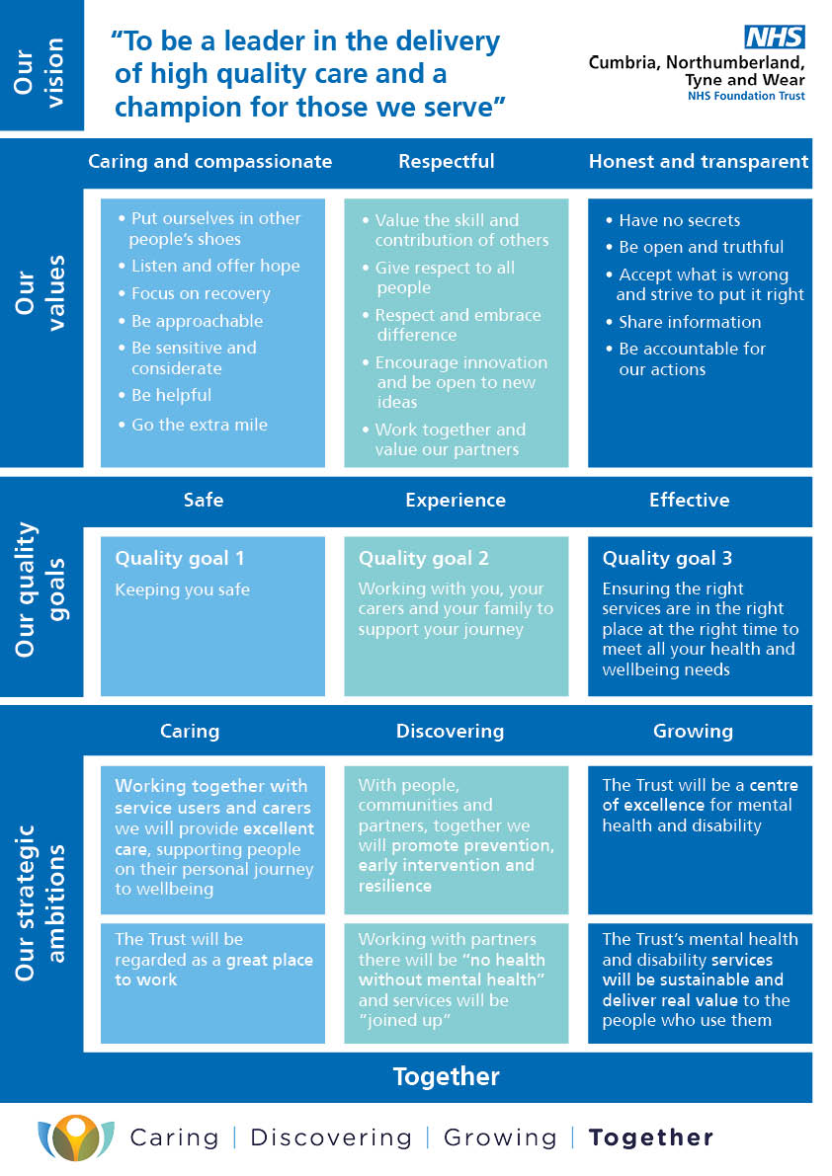
Longer Term Strategy

The Trust launched a refresh of its strategy in 2017 taking an inclusive approach over an eighteen-month period based on engagement and feedback from: service users and carers; staff; Clinical Commissioning Groups and other partner organisations; the Council of Governors; and the Board of Directors.

We have taken into account the national and local strategies that are relevant to the people using our services, carers, our staff and our organisation as a whole. The involvement work took many forms and some key themes emerged. These were:

- Including people
- Being people centred
- Recovery
- Developing pathways
- Real support
- Wellbeing
- Quality
- Expertise
- Listening

The feedback from all of those involved has helped us shape our strategy, identify what is important and determine our strategic ambitions. The title of our strategy is:

‘Caring, discovering, growing: Together’

Our strategy is being reviewed as part of the national Community Services Transformation Programme and in the context of the establishment of Integrated Care Systems as statutory organisations subject to legislation.

The challenges and opportunities

As the NHS strives to continue to provide high quality services and to live up to the high expectations of patients and the public, we must have regard to today’s challenges and anticipate the challenges of the future. People are living much longer which is good news, but an ageing population presents a number of serious challenges for the health and social care system.

The cost of providing care is getting more expensive and the NHS is facing these challenges at a time of unprecedented austerity and adjusting to an era of much tighter public finances.

We are seeking expressions of interest for our Board of Directors while going through what is, undoubtedly the most challenging time the world has seen in recent times.

The Covid-19 pandemic has had a profound global impact and has changed the lives of people across the world forever. People have never before had to think about their personal finances, mental and physical health and wellbeing, the wider economy, climate change, and job security, all at the same time.

Having said that, the pandemic has also brought about things we never thought we
could do, or ever thought we would do including the way we deliver services. We recognise that we need to use this to go further, to push for better, and re-imagine the future so that we can better support the people and communities that we serve.
There is no question that the demand for our services will increase as a result of the Pandemic and alongside this, mental health in particular has never had a higher profile in society.

After many years of fighting hard to challenge the stigma associated with mental ill health, the tide is finally turning. Celebrities, pop stars and the Royal family have opened up about their personal experiences. Change for the better is happening, and more is to come. The next five years will be a time of change for the whole of the NHS and also for CNTW.

What is an Integrated Care System?

Now, more than ever before, health and care services need to work together to deliver the right care, at the right time and in the best place. The NHS Long Term Plan, published 7 January 2019, makes it clear that integrated care systems (ICS) are central to bringing together local organisations, to redesign care and improve health.

Creating an ICS for the North East and North Cumbria is not about developing a new organisation or structure. It’s about looking at ways of working differently for the benefit of all patients and staff. An integrated care system will bring together health and social care organisations to agree joint priorities and decide how best to deliver efficient services where there is a common need or opportunity. By collaborating and making best use of combined resources, including technology, data, money and our workforce, we have a shared focus on improving the health and wellbeing of people in all communities.

An Integrated Care System will support joint decisions and make it easier to work ‘at scale’ on common issues which are bigger than one organisation. This will result in planning and tailoring care for local populations and communities by working across local boundaries to reduce some of the costs associated with planning and delivering services, in addition to sharing what works best to improve the health of local people.

Accountability Framework

Elect/Appoint Appoint Appoint

Our Members (including service users, staff and stakeholders)

As a Public Benefit Corporation CNTW has members. We have four membership constituencies to represent stakeholder interests:

- Public constituency;
- Service users and carers constituency;
- Staff constituency;
- Partner organisation constituency.

Members elect public, service user and carer Governors into post, and key partner organisations appoint representatives to the Council of Governors. Membership ensures that NHS Foundation Trusts truly represent and understand the needs of their local communities in the development of services and delivery of strategy and objectives.

The Trust’s Constitution provides further detail on the governance of the Trust and the accountability framework. The Constitution is available at https://improvement.nhs.uk/about-us/corporate-publications/publications/Northumberland-Tyne-and-Wear-NHS-Foundation-Trust/

The Council of Governors

The duties of the Council of Governors include:

- To hold the Non-Executive Directors to account for the performance of the Board of Directors, which includes ensuring the Board of Directors acts so that the Trust does not breach the terms of its Provider Licence.
- To represent the interests of the members of the NHS Foundation Trust as a whole and the interests of the public.
- Appoint and, if appropriate, remove the Chair.
- Appoint and, if appropriate, remove the other Non-Executive Directors.
- Decide the remuneration and allowances, and other terms and conditions of office, of the Chair and the other non-executive directors.
- Approve (or not) any new appointment of a Chief Executive.
- Appoint and, if appropriate, remove the Trust’s Auditor.
- Contribute to the Trust Forward Planning process.
- Approve significant transactions (including mergers, acquisitions etc.).
- Approve amendments to the Trust’s constitution;

The role of the Board of Directors

The Board of Directors consists of eight Non-Executive Directors including the Chairman and seven Executive Directors including the Chief Executive. They are collectively responsible for the exercise of the powers and the performance of the Trust.

As a unitary Board all directors have joint responsibility for every decision of the Board of Directors and share the same liability. This does not impact upon the particular responsibilities of the Chief Executive as the accounting officer.

The general duty of the Board and of each director individually, is to act with a view to promoting the success of the organisation so as to maximise the benefits for the members of the Trust as a whole and for the public.

Its role is to provide entrepreneurial leadership of the Trust within a framework of prudent and effective controls, which enables risk to be assessed and managed. It is responsible for:

- Ensuring the quality and safety of healthcare services, education, training and research delivered by the Trust and applying the principles and standards of clinical governance set out by the Department of Health, NHS England, the Care Quality Commission, and other relevant NHS bodies.
- Setting the Trust’s vision, values and standards of conduct and ensuring that its obligations to its members are understood, clearly communicated and met. In developing and articulating a clear vision for the Trust, it should be a formally agreed statement of the Trust’s purpose and intended outcomes which can be used as a basis for the Trust’s overall strategy, planning and other decisions.
- Ensuring compliance by the Trust with its licence, its constitution, mandatory guidance issued by Monitor, relevant statutory requirements and contractual obligations.
- Setting the Trust’s strategic aims at least annually, taking into consideration the views of the Council of Governors, ensuring that the necessary financial and human resources are in place for the Trust to meet its priorities and objectives and then periodically reviewing progress and management performance.
- Ensuring that the Trust exercises its functions effectively, efficiently and economically.

The Board of Directors keeps its performance and effectiveness under on-going review. It undertakes a self-assessment of effectiveness supported by post Board of Directors’ meeting reflections, Board time outs, a development programme, the review of governance arrangements and its committees’ annual self-assessment exercise.

The Board of Directors maintains continuous oversight of the Trust’s risk management and internal control systems with regular reviews covering all material controls, including financial, operational and compliance controls. The Board of Directors reports on internal control through the Annual Governance Statement as part of the Annual Report and Accounts.

The Board of Directors meets in public ten times per year (excluding Board Away Days).

The appointment of Non-Executive Directors requires approval by the majority of the Governors attending the relevant general meeting.

Non-Executive Director (this vacancy) Role Description

Accountable to: Chairman of the Council of Governors and Board of Directors
Location: Home based, travel to various trust sites is required.
Time commitment: Approximately four days per month
Remuneration: £13,500 NED allowance
Term of appointment: Three years with an opportunity to renew or re-apply

Overall purpose

- Commit to working to, and encouraging within the Trust, the highest standards of probity, integrity and governance and contribute to ensuring that the trust’s internal governance arrangements conform to best practice and statutory requirements.
- Provide independent judgement and advice on issues of strategy, vision, performance, resources and standards of conduct and constructively challenge, influence and help the executive board develop proposals on such strategies.
- In accordance with agreed board procedures, monitor the performance and conduct of management in meeting agreed goals and objectives and statutory responsibilities, including the preparation of annual reports and annual accounts and other statutory duties.

Responsibilities

- Contribute to the determination of appropriate levels of remuneration for Executive Directors.
- Participate in your appointed committees and take an active part in other committees (including the remuneration committee) established by the Board of Directors to exercise delegated responsibility.
- Chair the Resources and Business sub-committee of the Board and the Board overseeing our major capital project - CEDAR
- Bring independent judgement and experience based on commercial, financial, capital investment and governance expertise from outside the trust and apply this to the benefit of the trust, its stakeholders and its wider community.
- Assist fellow directors in setting the trust’s strategic aims, ensuring that the necessary financial and human resources are in place for the trust to meet its objectives, and that performance is effectively monitored and reviewed.
- Assist fellow directors in providing entrepreneurial leadership to the trust within a framework of prudent and effective controls, which enable risk to be assessed and managed.
- Assist fellow directors in setting the trust’s values and standards and ensure that its obligations to its stakeholders and the wider community are understood and fairly balanced at all times.
- Engage positively and collaboratively in board discussion of agenda items and act as an ambassador for the Trust in engagement with stakeholders including the local community, dealing with the media when appropriate.
- Sitting on the minimum number of Mental Health Act panels per annum.

Communications and Working Relationships
- Ensure the effectiveness and constructive dialogue and promote harmonious relations with the following bodies as relevant:
  - Board of Directors
  - Council of Governors
  - Stakeholders in the trust’s community
  - National healthcare stakeholders; and
  - Regulators including NHS England/NHS Improvement and the Care Quality
Commission
- Ensure the provision of accurate, timely and clear information to directors and governors, so that within the boundaries of probity, good governance and risk, the trust meets all its statutory objectives and remains within the terms of its authorisation.
- Participate fully in the work of the Board of Directors and of governors and maintain appropriate links with the Chief Executive and individual directors, as well as with the wider local and national health and social care community.
- Develop high level relationships with key stakeholders, including the trust’s financiers, but ensuring that the interests of all stakeholders are fairly balanced at all times.
- Bring balance to the use and influence of external advisers.
- Represent the trust’s views with national, regional or local bodies or individuals and ensure that the views of a wide range of stakeholders are considered.

Corporate Responsibilities

- To work at all times in the interests of patient/service user and carers.
- Contribute to the strategic vision of the Trust and the identification of the Trust’s objectives.
- Ensure compliance with all corporate governance and statutory requirements.
- Responsible for own health and safety and the health and safety others at work.
- Uphold the values of the trust, to be an appropriate role model and to ensure that the board promotes equality and diversity for all its patients, staff and other stakeholders.
- Be an ambassador for the trust; be knowledgeable and aware of local issues and assist the trust in its efforts to support local regeneration as a major employer.
- Set an example on all policies and procedures designed to ensure equality of employment; Staff, patients and visitors must be treated equally irrespective of gender, ethnic origin, age, disability, sexual orientation, religion etc.

Personal Responsibilities

- Adhere to the Nolan Principles.
- Take responsibility for self-development on a continuous basis, undertaking this in work or development opportunities as appropriate.
- Participate in personal objective setting and review, including the creation of a personal development plan.
- Act as an ambassador for the trust and its services.
- Promote the objectives and ethos of the Trust at all times.
- Respect confidentiality of any confidential information shared during the course of employment.
- To contribute to the work of the board through debate, scrutiny and challenge with particular focus on issues of strategy, performance and governance.
- To undertake a minimum of four visits per annum to wards or other operational areas within the Trust.
- To participate in the work of one or more of the Board sub-Committees, ensuring appropriate challenge and scrutiny, particularly in relation to the presentation and analysis of performance reports and the basis for assurances in relation to compliance with key targets.
- To contribute to the determination of appropriate levels of remuneration for executive directors and other senior managers, and any other work in relation to this committee's terms of reference.

Person Specification

E = Essential D = Desirable

Qualifications

Professional qualification in a relevant discipline or relevant experience E
Degree or equivalent D
Further qualification in management D

Experience

Experience of leadership in a large and complex organisation E
Experience at board level in a large and complex organisation D
Experience in chairing boards or committees D

Skills and Abilities

Highly developed leadership skills E
Excellent communication skills E
Effective influencing skills E
Sound networking skills E
Highly developed analytical skills E
Highly developed interpersonal skills E
Effective team player E
Ability to provide constructive challenge E
Ability to manage conflict E

Knowledge

Best practise in corporate governance E
Strategy development E
Performance management E
Broad understanding of the NHS D

Personal Attributes

Politically aware E
Gravitas E
Assertive E
Pro-active E
Enquiring E
Sound judgement E
Commitment to self-development E

The Trust would welcome applications from people with experience in commercial and business planning including contracting and project management, experience of leading through complex change management would be welcome, as well as understanding of managing significant business transactions, and organisational business planning.

We value and promote diversity and are committed to equality of opportunity for all and all appointments are made on merit. We believe that the best boards are those that reflect the communities they serve, we particularly welcome applications from women, people from the black and minority ethnic communities, and disabled people who we know are under-represented in non-executive roles.

How to apply

Applications can be made via http://trac.jobs/ or https://www.jobs.nhs.uk/

If you have any queries, please contact Debbie Henderson, Director of Communications and Corporate Affairs

Telephone: 0191 2457290 or 0191 2456823
Email: Debbie.Henderson@ntw.nhs.uk

Application process

The closing date for applications - Midnight 29th September 2021

Shortlisted candidates will have the opportunity to informally meet the Chair and Chief Executive prior to the formal interviews which will be held on 19th October 2021.

This is a Governor-led appointment and the Panel will comprise of Members of the Nominations Committee who will make a recommendation to the Council of Governors at a general meeting after which a formal offer will be made to the successful candidate.

September 2021
Cumbria, Northumberland, Tyne and Wear NHS Foundation Trust

